SafeScan Community: Design Document
Oct 16, 2026 · @Tinenyasha Sibanda

Overview
SafeScan checks a scanned QR code for a malicious link and for a physical sticker placed over the original, and feeds anonymous reports into an open community threat database.
The app returns a verdict of Safe, Suspicious, or Dangerous built from Google Safe Browsing, URL heuristics, and community data. A separate heads-up appears when the code looks like it has a sticker over it. Reports with an approximate location also feed a map of tampering hotspots. Version one runs on AWS at zero cost.
Component | Status
QR decoding with OpenCV | Python prototype
Safe Browsing check, URL heuristics | Built on Cloudflare Workers, being rebuilt on AWS
Sticker detection (texture, sheen, shadow lines) | In development in Python, React Native port pending
React Native client in TypeScript | To build
AWS database and scan logic | Designed here, presented first
Community reports, hotspots | Designed here

Architecture
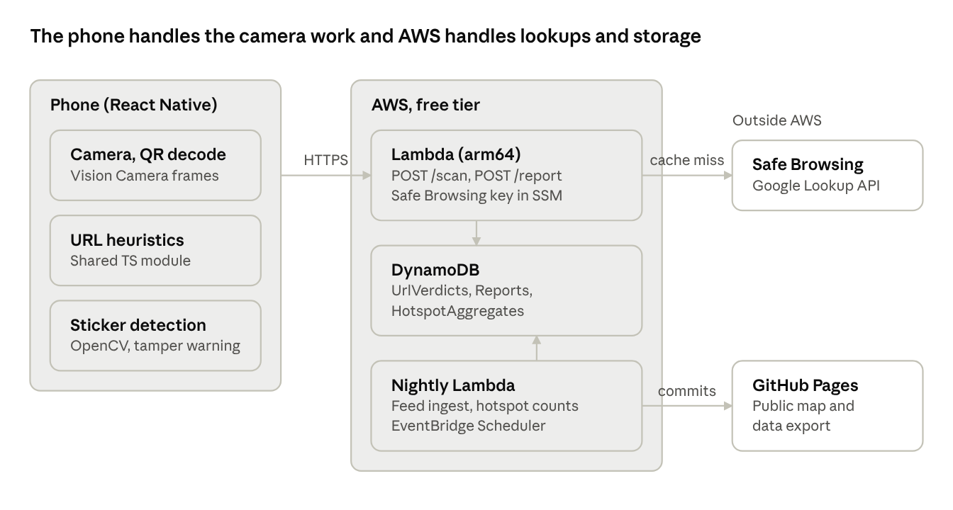
architecture · phone, AWS, 2 outside services
The app sends a URL to one Lambda, which reads and writes DynamoDB and calls Safe Browsing only on a cache miss. A nightly Lambda publishes hotspot data to GitHub Pages, and the phone never uploads an image.

Scan logic
A scan produces two outputs that never mix: a verdict built only from URL evidence, and a tamper warning built only from the camera image.
- The camera decodes the QR code on the phone.
- The client normalizes the URL (lowercase host, decoded punycode, tracking parameters and fragment removed) and computes its SHA-256 hash.
- Heuristics score the URL for an IP address as host, punycode lookalikes, shorteners, uncommon TLDs, very long paths, login or payment keywords, and nested redirect parameters.
- Sticker detection scores the same camera frame on the phone and returns a tamper warning (next sections).
- The client sends POST /scan with the URL, its hash, the tamper warning, and an optional geohash.
- The Lambda looks up the hash in UrlVerdicts. A fresh row is returned at once.
- On a miss, it checks for a verified community entry, then calls Safe Browsing, and caches the answer.
- It combines Safe Browsing, community status, and heuristic score into one verdict and returns it with the reasons.
The heuristics live in one TypeScript module used by both the app and the Lambda. The app uses it for instant feedback, and the Lambda recomputes the score so it never trusts flags sent by a client.
Verdict | Condition
Dangerous | Safe Browsing match, or a verified community entry
Suspicious | No match, heuristic score at or above the suspicious threshold
Safe | Neither of the above. Means no known threat found, not guaranteed safe
When the backend cannot be reached or returns a throttle error, the app shows a heuristics-only result labeled as limited.

Safe Browsing and cache invalidation
Safe Browsing is called only on a cache miss, and a cached answer never outlives what Google allows. This moves the Cloudflare version's cache and invalidation into DynamoDB.
Version one uses the Lookup API, which sends the full URL to Google. The Update API keeps a local hash-prefix database and is more private, so it is listed as a later upgrade. The API key sits in SSM Parameter Store, whose standard tier is free.
Result | Cache expiry
Match | fetchedAt plus the cacheDuration Google returns (confirm the field in the current reference)
No match | fetchedAt plus a short negative TTL, set by the team. Kept short because a clean URL can be flagged later
Three mechanisms keep the cache honest:
- Every read compares expiresAt to the current time and treats an expired row as a miss. DynamoDB's own TTL cleanup can lag by up to 48 hours, so it is not relied on for correctness.
- A miss triggers a fresh Safe Browsing call, a new row, and the response.
- When a community report becomes verified, a DynamoDB Streams trigger overwrites that URL's row immediately, so a cached clean result cannot hide a confirmed threat.
A poster scanned hundreds of times costs one Google call per expiry window, which also protects the API quota.

AWS database design
Three DynamoDB tables cover the scan cache, the community reports, and the hotspot counts, and each query the app needs maps to one key or index.
Table | Key | Main fields
UrlVerdicts | urlHash | url, verdict, threatTypes, source (safebrowsing, community, feed), fetchedAt, expiresAt, ttl
Reports | reportId | urlHash, url, category, note (280 characters), geohash5 (optional), tamperWarning, urlStatus, installIdHash, createdAt
HotspotAggregates | geohash5 | reportCount, tamperCount, distinctUrls, lastSeen
urlStatus (pending, corroborated, verified, rejected) and tamperWarning are separate fields, so a report can be a verified malicious URL with no sticker, or the reverse.
Query | Served by
Cached verdict for a scanned URL | UrlVerdicts primary key
Distinct reporters of one URL | Reports index on urlHash and createdAt
Recent reports in an area | Reports index on geohash5 and createdAt
Public list of verified threats | Reports index on urlStatus and createdAt
Hotspot counts per area | HotspotAggregates primary key
The free allowance is 25 read and 25 write capacity units, shared across all tables and indexes, so each table and index gets between 1 and 5 units in provisioned mode, with auto scaling off. Confirm the current limits in the console before deploying.
A nightly Lambda can also load OpenPhish and URLhaus entries into UrlVerdicts with source set to feed. Check that PhishTank is currently open to new users before relying on it.

Sticker detection
Sticker detection runs entirely on the phone and produces a heads-up for the user. It never changes the verdict.
The pipeline uses classical computer vision with no reference image. It looks for signs that the code's surface does not match its surroundings: texture differences measured with local binary patterns (LBP), specular sheen from a glossy overlay, and shadow lines along a sticker's edge. The combined score maps to none, possible, or likely, with cutoffs the team sets once there is test data.
The warning text is about the physical code: "This code may have a sticker over it. Check that it came from a source you trust." It does not call the link bad, because businesses and event organizers do place new stickers over old codes, and the detector will have false positives.
In React Native, the likely route is a Vision Camera frame processor with an OpenCV binding such as react-native-fast-opencv. Confirm that library's current state on both iOS and Android before committing. A pure TypeScript port is probably too slow for live frames.
The image never leaves the phone. Only the warning level (and optionally a geohash) is sent with a scan or a report.
No accuracy numbers exist yet. The first test is a labeled photo set of real codes with and without stickers, shot under different lighting, used to pick the none, possible, and likely cutoffs.

Community reporting and verification
Anyone can report anonymously in under four taps, and nothing becomes public until independent evidence supports it.
Reporting flow
- After any scan, a "Report this QR code" button appears on the result, and a "Looks wrong" button appears on Safe results. The home screen has a report button for codes seen but not scanned, and the share sheet accepts suspicious links.
- The reporter picks what happened from chips: sticker over a real code, fake login page, asked for payment or personal info, or other.
- An optional note holds up to 280 characters. A location toggle is off by default and sends only an approximate area.
- Submit shows a short thanks and nothing else.
The URL, scan time, and tamper warning attach automatically. Photos are left out of version one because storing them needs S3.
Verification states
State | Meaning | Reached when
pending | Submitted, hidden from the public | On submit
corroborated | One independent signal agrees | A feed match, a Safe Browsing match, or a second distinct reporter
verified | Public and used in scans | A feed or Safe Browsing match, or N distinct reporters within window W plus a heuristic score of at least T, or maintainer approval
rejected | Kept for audit, never shown | Failed review, or the domain is on the allowlist
N, W, and T are set by the team. The URL claim and the sticker claim are verified separately. A tamper warning is evidence only for the sticker claim and never moves urlStatus.
Abuse controls without accounts
- The app creates a random install ID on first launch. The backend stores only its hash and uses it for rate limiting.
- Distinct reporters count by install hash and hashed IP, and votes alone never verify a URL.
- Reported domains found in the Tranco top list go to manual review instead of auto-verification, so a rival cannot mass-report a real business.
- A contact address for disputes lets a domain owner appeal.
- A small admin script lists pending reports with their evidence, so three people can review them.

Hotspots and public data
A scheduled job turns reports into area counts, and a static map and a data export publish them for free.
An EventBridge schedule runs a Lambda nightly. It groups Reports by geohash5 (cells of roughly 5 km), writes the counts to HotspotAggregates, and commits a JSON file to the project's GitHub repository. A MapLibre page on GitHub Pages reads that file, which keeps hosting and bandwidth at zero cost.
Two patterns are worth flagging:
- A tampering hotspot is a cell with repeated tamper warnings and changing URL hashes over time, even when each URL looks clean.
- A campaign is one URL hash appearing in many cells, which points to printed stickers distributed widely.
A cell appears on the map only after it reaches a minimum report count, set by the team, so a single report cannot point to one location.
The public export contains verified entries only: URL, category, status, and first and last seen. It leaves out notes, install hashes, and any location finer than the cell. Suggested licenses are ODbL or CC BY for the data and Apache-2.0 or MIT for the code.

Zero-dollar deployment and abuse controls
AWS has no hard spending cap, so version one stays free through design choices and a hard limit on how much traffic the backend accepts.
Piece | Choice
API | Lambda function URL on arm64, instead of API Gateway
Traffic cap | Reserved concurrency of about 5, so a flood is throttled and not billed
Database | DynamoDB in provisioned mode within the shared 25 and 25 unit allowance
API key | SSM Parameter Store standard tier, instead of Secrets Manager
Schedules | EventBridge Scheduler for the nightly jobs
Map and data export | GitHub Pages
Left out | WAF, Cognito, S3, Athena, Location Service, NAT Gateway
A budget alert at $1 warns the team, but it fires after spending starts and does not stop it. Newer AWS accounts may offer a free plan that blocks charges for a limited period, so check the console for it.
If the app gets popular, requests past the concurrency cap return a throttle error and the app falls back to a heuristics-only result. Per-install rate limits stop one device from consuming the whole allowance.
The backend logic stays in plain TypeScript modules that do not depend on AWS APIs, so it can move to the Cloudflare Workers free tier if AWS ever becomes a problem.

Paid upgrades funding would unlock
Funding turns the zero-cost prototype into a service that can run commercially, take accounts, and analyze data at scale. Costs are not estimated here and need checking against current AWS and vendor pricing.
Upgrade | What it adds
Google Web Risk API | The commercial counterpart of Safe Browsing, needed because Safe Browsing is free only for non-commercial use
AWS WAF | Rule-based protection and rate limiting on the public endpoint
Amazon Cognito | Accounts for community members and trusted reviewers
Amazon S3 | Report photos, versioned data exports, and raw data for analysis
Athena (optionally QuickSight) | SQL and dashboards over reports for hotspot analysis
Amazon SageMaker | Training and hosting the ML scoring layer on PhishTank, OpenPhish, URLhaus, and Tranco data
Amazon Location Service | A managed map for the hotspot view
Graviton compute | Server-side image analysis through the COOL path, as an option beyond on-device detection
VirusTotal paid tier | Higher quotas for URL reputation checks

Implementation plan, risks, and open values
The first milestone is one working scan from the phone to DynamoDB, and everything else builds on that path.
- Create the new repo from the original as a template, add client, backend, infra, cv, and docs folders, and check the copied files for secrets.
- Define the infrastructure as code (CDK or SAM): Lambda, function URL, tables, SSM parameter, and budget alerts.
- Build the vertical slice: POST /scan to Safe Browsing to UrlVerdicts, tested with curl.
- Write the shared TypeScript heuristics module and use it in the Lambda.
- Build the React Native scan screen, then port sticker detection through OpenCV.
- Add the reports route, verification states, feed ingest, and hotspot job.
- Publish the GitHub Pages map and the public data export.
Risk | Mitigation
OpenCV in React Native is hard to get working on both platforms | Test the binding early, with a fallback of simpler on-device checks
Safe Browsing terms limit commercial use | Stay non-commercial, plan the Web Risk API for later
Mass reporting against legitimate sites | Tranco review, distinct-reporter rules, dispute contact
Free-tier limits exceeded | Concurrency cap, per-install limits, heuristics-only fallback
Sticker warnings fire too often and get ignored | Tune cutoffs on a labeled photo set before release

Value the team sets | What it controls
Negative cache TTL | How long a clean result is reused
Suspicious threshold | Heuristic score where a URL becomes Suspicious
Tamper cutoffs | Scores for none, possible, and likely
N, W, and T | Reporters, time window, and heuristic score needed to verify a report
Report rate limit | Reports allowed per install per hour
Minimum hotspot count | Reports needed before a cell shows on the map

